

Sign Sync – User Sync Tool Integration

User Guide

v1.0

Table of Contents

Overview 2

Disclaimer 2

Features 2

Prerequisites 2

Deployment 3

Configuration 3

How To – Create Adobe Sign Integration 5

How To – Synchronization 7

Admin Console 7

LDAP 11

How To – Assigning Privileges 12

# Overview

Sign Sync allows for an automated process of moving users over from Admin Console into your Adobe Sign. Sign Sync works as an addition add on to the Adobe User Sync Tool, which allows you to synchronize entities within your LDAP over to Adobe Admin Console. Once users are assigned into Adobe Admin Console with Sign entitlements, Sign Sync will grab those users and port them over to Adobe Sign placing in their corresponding groups along with account privileges.

# Disclaimer

Sign Sync works as a one-way sync from Adobe Admin Console to Adobe Sign. Any changes made in Adobe Sign such as group creation, user creation, privileges, or moving users to different groups will be reverted back to the current state in Admin Console. Changes should be made either from your LDAP or Admin Console depending how you have your mapping set up.

# Features

The following is a list of automated features currently possible with Sign Sync.

|  |  |
| --- | --- |
| Features | Sync users from Admin Console over into Sign Console. |
| Group Creation | New groups created in Admin Console will be synced over to the Sign Console. |
| User Privileges | User privileges set in Admin Console will sync over to Sign Console. |
| Ignore Groups | Ability to ignore specific groups defined in a configuration file. |
| Ignore Admin Privileges | Ability to ignore specific admin roles to be synced over in Sign. |

# Prerequisites

This is a list of all prerequisites that you should checked off to verify that you have what is needed to start the deployment process. Please make sure you have all the prerequisites set up before using Sign Sync.

|  |  |
| --- | --- |
| Python 3.7 | Python version 3.7 is recommended as the User Sync Tool 2.3 is running python 3.7. [Click Me](https://www.python.org/downloads/release/python-370/) |
| Adobe Sign Integration Key | The integration key to your Adobe Sign Console. [Click Me](https://www.adobe.io/apis/documentcloud/sign/docs/overview.html) |
| Admin Console | Your Admin Console integration. [Click Me](https://adobe-apiplatform.github.io/umapi-documentation/en/) |
| Adobe User Sync Tool | Running version 2.3 of User Sync Tool. [Click Me](https://adobe-apiplatform.github.io/user-sync.py/en/) |
| Text editor | This will be required to edit any configuration files. |

# Deployment

Sign Sync works alongside Adobe User Sync Tool. Please make sure that all dependencies and packages are set up correctly for User Sync Tool. If so, you should be able to perform a [test run](https://adobe-apiplatform.github.io/user-sync.py/en/success-guide/test_run.html). Once a successful run of User Sync Tool is confirmed, you can start configuring the Sign Sync feature into User Sync Tool.

# Configuration

Sign Sync uses information from User Sync Tool configuration files to get access to both Admin Console and LDAP. Please make sure that you follow the instructions on how to set up the configuration files correctly. Please [click here](https://adobe-apiplatform.github.io/user-sync.py/en/user-manual/configuring_user_sync_tool.html) for more details on setting up the UST configuration files.

Sign Sync currently uses one configuration file called connector-sign-sync.yml.

**server:  
 host:   
 endpoint_v5:** /api/rest/v5  
 **endpoint_v6:** /api/rest/v6  
  
**enterprise:  
 integration:  
 email:  
  
conditions:  
 connector:  
 version:  
  
umapi_conditions:  
 product_group:  
 account_admin_groups:  
 ignore_admin_groups:**   
 **multi_group:** 'no'  
 **ignore_groups:  
  
  
ldap_conditions:  
 attributes:**

Figure 1: connector-sign-sync.yml

#### Server

* Host: Adobe Sign Host URL
* Endpoint_v5: Adobe Sign API version 5 endpoint (shouldn’t be changed)
* Endpoint_v6: Adobe Sign API version 6 endpoint (shouldn’t be changed)

#### Enterprise

* Integration: Integration key for Adobe Sign
* Email: Account admin email associated with that Adobe Sign

#### Conditions

* Connector: Let the application know which platform you want to sync up with.
  + Enter only one of the following: [umapi or ldap]
* Version: Let the application know which API version to use.
  + Enter only one of the following: [v5 or v6]

#### UMAPI Conditions

* Product_Group: The product group name, which has Sign entitlement.
  + Enter one or more separated by a comma:
  + Ex: HR – Recruiting, Marketing, Engineering
* Account_Admin_Groups: Grant account admin access if user has listed attribute.
  + Enter one or more of the following:

[_org_admin, _deployment_admin, _support_admin, _product_admin]

* Ignore_Admin_Groups: Don’t give account admin access to users with listed attribute.
  + Enter one or more of the following

[_org_admin, _deployment_admin, _support_admin, _product_admin]

* Multi_Group: Allow the multigroup synchronization when Adobe Sign decides to adopt this feature.
  + Enter only one of the following: [yes or no]
* Ignore Group: Allows the application to ignore specify group names.
  + Enter one or more names separated by a comma: [Test1, Test2]
  + Enter [None] if you don’t want to ignore any groups

#### LDAP Conditions

* Attributes: Data fields that will be queried when searching for a user in LDAP.
  + Enter one or more of the following separated by a comma:
  + company, homePhone, mail, mobile, title, givenName, sn, objectGUID, memberOf

# How To – Create Adobe Sign Integration

This section will show you how to create an Adobe Sign Integration Key.

1. Log into you Adobe Sign Console.
2. Click Account
3. Locate Adobe Sign API tab
4. Click API Information

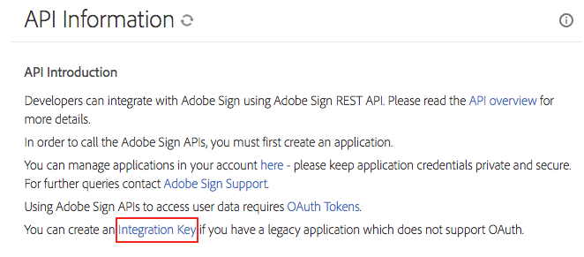

Figure 2: Sign Integration Key Location

1. Click the integration key link.
   1. If you do not see the integration link, please contact Support for assistance

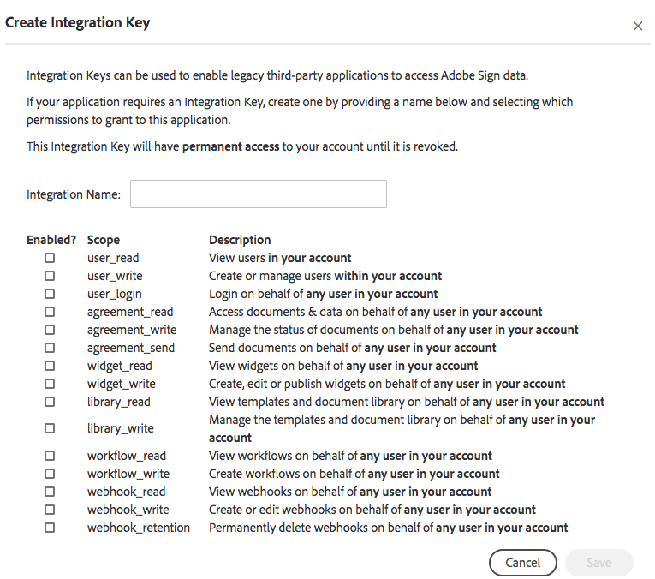

Figure 3: Sign Integration Key Creation

1. Enter a name associated with this integration
2. Select scopes associated with this integration. For more information, please [click here](https://secure.echosign.com/public/static/oauthDoc.jsp).
3. Click save
4. Go to the personal preferences tab and select access token
5. Find your integration and click it

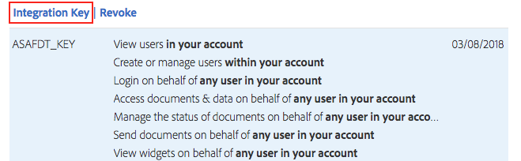

Figure 4: Integration Key Location

1. Click the integration key link and your integration key should display like the image below:

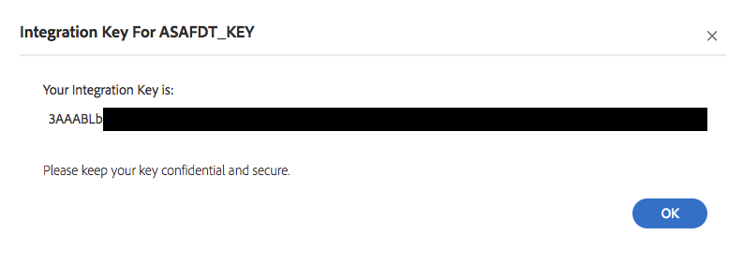

Figure 5: Integration Key

# How To – Synchronization

The following section will explain how to use the Adobe Admin Console & Active Directory as an LDAP service to start setting up your synchronization. You can either directly manage/sync users directly from Admin Console or LDAP depending how your mapping is set under the group configuration in user-sync-config.yml.

## Admin Console

1. Log into your [Adobe Admin Console](https://adminconsole.adobe.com/).
2. Click overview
3. Find your Adobe Sign – Enterprise account and click it. This will take you to the product profile for the account shown below:

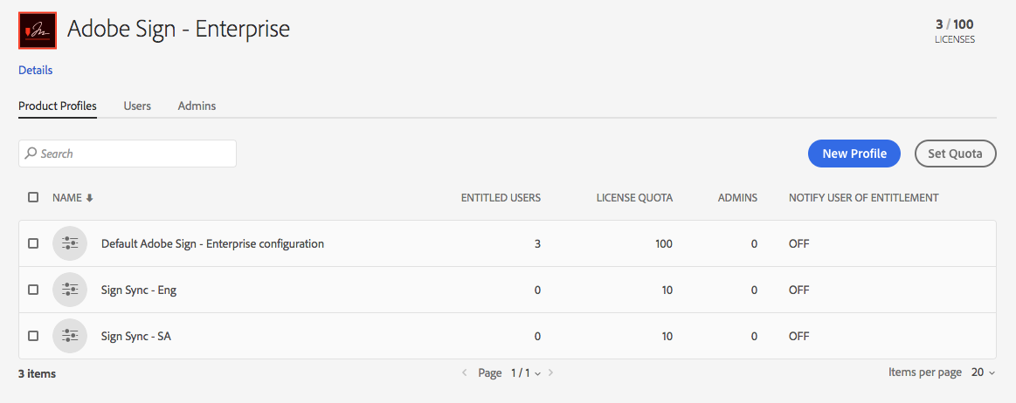

Figure 6: Adobe Admin Console Product Profile View

1. Locate your target product profile. For the purpose of this demonstration, we will be using Sign Sync – Eng & Sign Sync – SA as the product profile.
2. Open the connector-sign-sync.yml file located in the following file path:  
   “location to User Sync Tool folder/user-sync.py/user-sync/sign-sync”
3. Enter the product profile name in product_profile under umapi_conditions as follow:



Figure 3: Connector-sign-sync.yml

1. Log into your server where your active directory is hosted on and open up Active Directory Users & Computers. You should see the following screen:

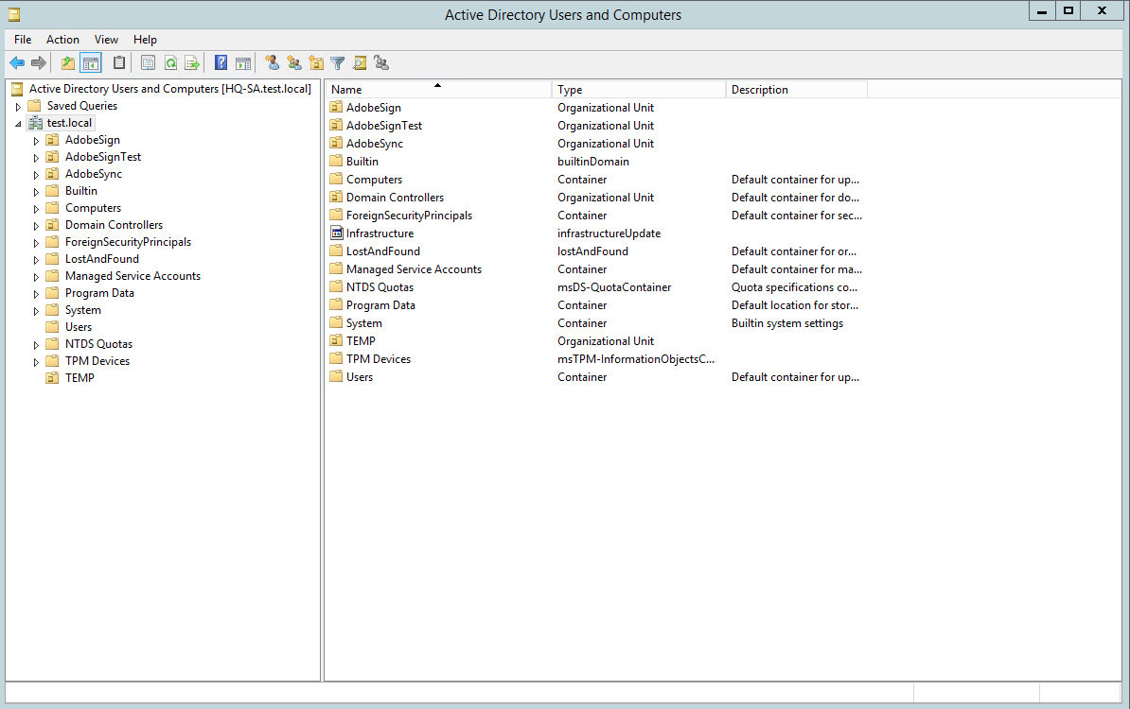

Figure 7: Active Directory Users and Computers

If you already have an organizational unit named Groups in the sub directory of your domain, in this case it’s test.local, then skip to step 10.

1. On the right panel, right-click on your domain and navigate to new and click organizational unit.

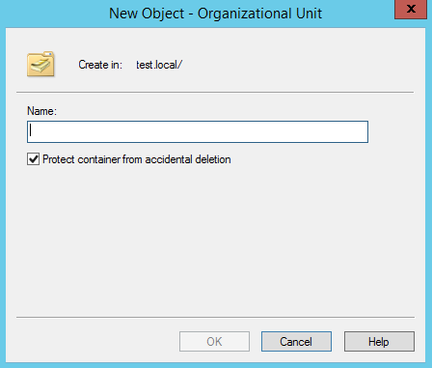

Figure 8: Organizational Unit Creation Menu

1. Name the organizational unit Groups and press OK.
2. Navigate into the Groups organizational unit and on the right panel right-click and navigate to new and click groups.

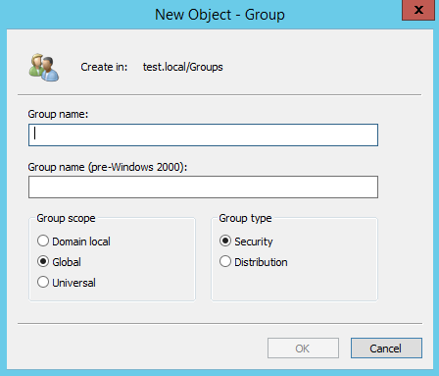

Figure 9: Group Creation Menu

1. Enter a name to associate your product profile with in LDAP Groups and press OK. Please see table below for an example of a name association.

|  |  |
| --- | --- |
| **Admin Console Product Profile** | **LDAP Group Name** |
| Sign Sync - ENG | ADOBE_SIGN_SYNC_ENG |
| Sign Sync - SA | ADOBE_SIGN_SYNC_SA |

1. Open up the user-sync-config.yml located in “location to UST folder/user-sync.py/user-sync/sign-sync”
2. Locate the groups setting under directory_groups.
3. Here is where you’ll map the following directory group to the Admin Console product profile.
   1. Directory_group: Name used in LDAP
   2. Adobe_groups: Name in Adobe Admin Console

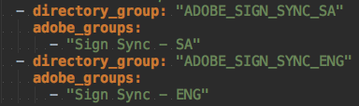

Figure 10: Group Configuration Under Directory_Users in user-sync-config.yml

1. Once the groups have been created and mapped, all that’s left is assigning users into their respective group.
2. Locate a user in your active directory and right-click on the user.

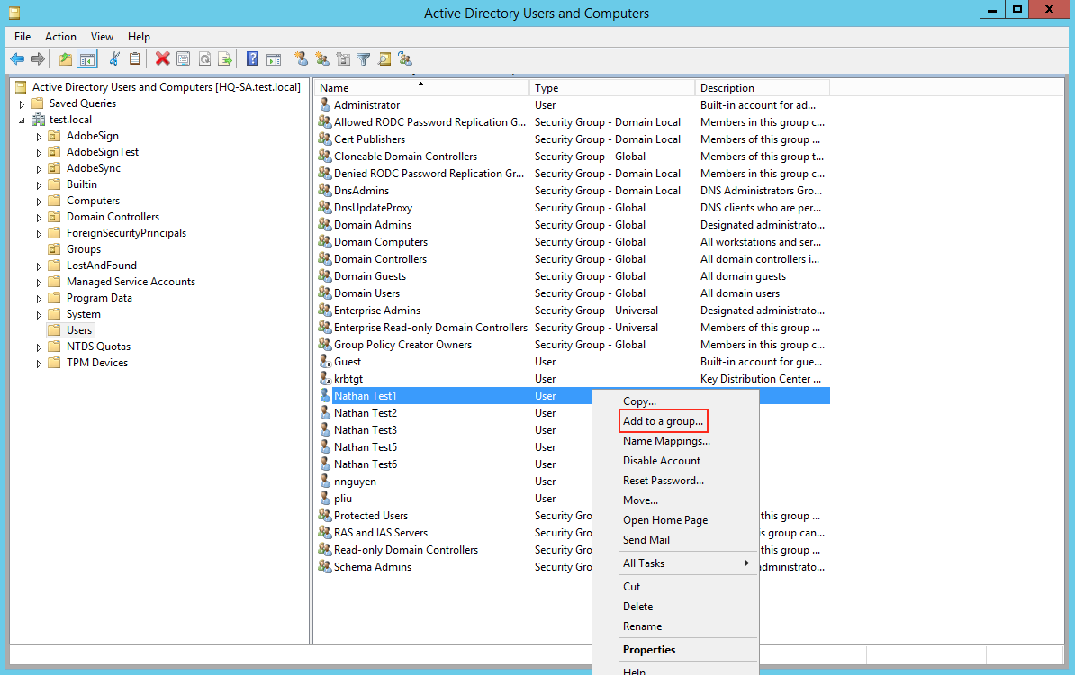

Figure 11: Adding User to Group Location

1. Click Add to a Group…

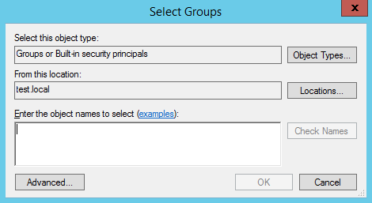

Figure 12: User Group Assignment Menu

1. Enter the group name you want to assign the user to as part of that product profile in the Admin Console.
2. Run the User Sync Tool with the following filters “--process-groups --users mapped”
3. New users will be created and place into your Users tab in the Admin Console.
4. Assign them to a user group in the Admin Console.
5. During the next synchronization iteration, the users will be placed into the corresponding groups in Adobe Sign.

## LDAP

1. Follow steps 1-11 in the Admin Console setup above.
2. To sync users directly into Admin Console Groups and over to Adobe Sign Groups, create additional groups in your active directory in the Groups organizational unit to match the user groups in LDAP.  
   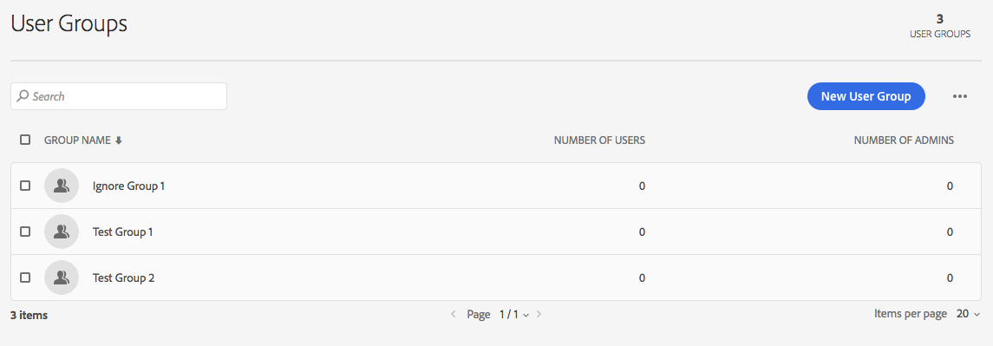

Figure 13: User Groups View in Admin Console

|  |  |
| --- | --- |
| **Admin Console Group** | **LDAP Group Name** |
| Test Group 1 | ADOBE_TEST_GROUP_1 |
| Test Group 2 | ADOBE_TEST_GROUP_2 |

Here is where you’ll map the following directory group to the Admin Console product profile.

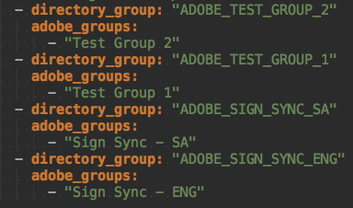

Figure 14: Group Configuration Under Directory_Users in user-sync-config.yml

When assigning users to groups, please make sure you assign them a product profile and then assign them into a user group. Adobe Sign currently doesn’t support multiple group assignments, so please make sure users are only assigned to one group.

1. Follow steps 15-22 in the Admin Console setup above.

# How To – Assigning Privileges

This section will explain how to assign privileges so it will sync over to Adobe Sign. Privileges must be assigned through the Admin Console. Privileges assigned through Sign Console will be overwritten when an iteration of the sync occurs.

1. Log into your Adobe Admin Console.
2. Click the Users tab in the navigation menu.
3. Select the user you would like to assign privileges to.
4. On the right panel that pops out from the side, click on the … button and click edit admin rights.

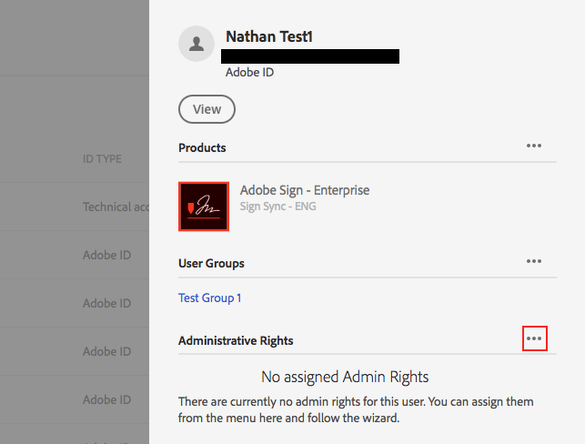

Figure 15: User Information from Admin Console

1. There are five account settings that you can enable for the user. The application will use these settings to determine if a user is an ACCOUNT ADMIN, GROUP ADMIN, or a NORMAL USER in Sign.

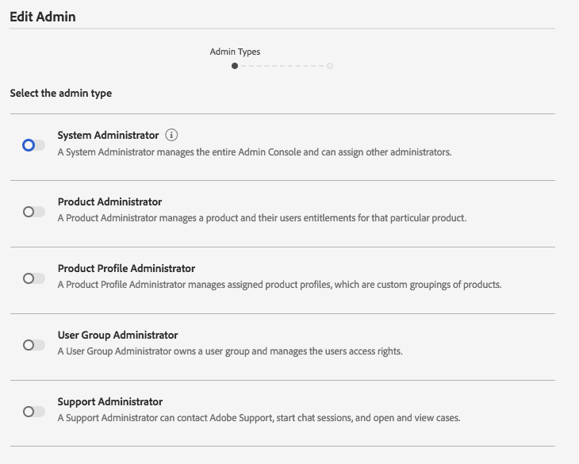

Figure 16: User Admin Privileges Page

* 1. ACCOUNT ADMIN (Select one of the following and configure it into your connect-sign-sync.yml file)
     1. System Administrator
     2. Product Administrator (Best option since it doesn’t interfere with Admin Console Privileges)
     3. Product Profile Administrator
     4. Support Administrator
  2. GROUP ADMIN
     1. User Group Administrator
  3. NORMAL USER
     1. Select None

1. Click Next on the bottom of the page.
2. Click Save to save new changes.